LAB 3

CSC 1310 Fall 2025
GitHub Copilot Agent Mode and OOP Design with Binary Search

Concepts for Lab 2
- Object-Oriented design with three interrelated classes
- Responsible and documented use of GitHub Copilot in Agent Mode
- File Input & Output with CSV format
- Driver program design to test multiple classes

Optional Paired Programming Assignment
Students may choose to complete this lab in pairs. If you work in pairs, make sure all your source files are identical that are uploaded to ilearn (except for the lab report proof screenshot). Also, follow the driver/navigator model:
- Driver: controls the keyboard and writes the code.
- Navigator: reviews each line, keeps focus on design and requirements.
- Switch roles every 15 minutes.
- Try the VS Code Extension called Live Share which allows users to collaborate on a single file from different computers at the same time. Once you install it, look at the bottom left of VS Code and look for live sharing, which will copy a link that you can send to anyone you want to collaborate with. Note: we have noticed that sometimes Live Share doesn’t work for people but it is worth a try.
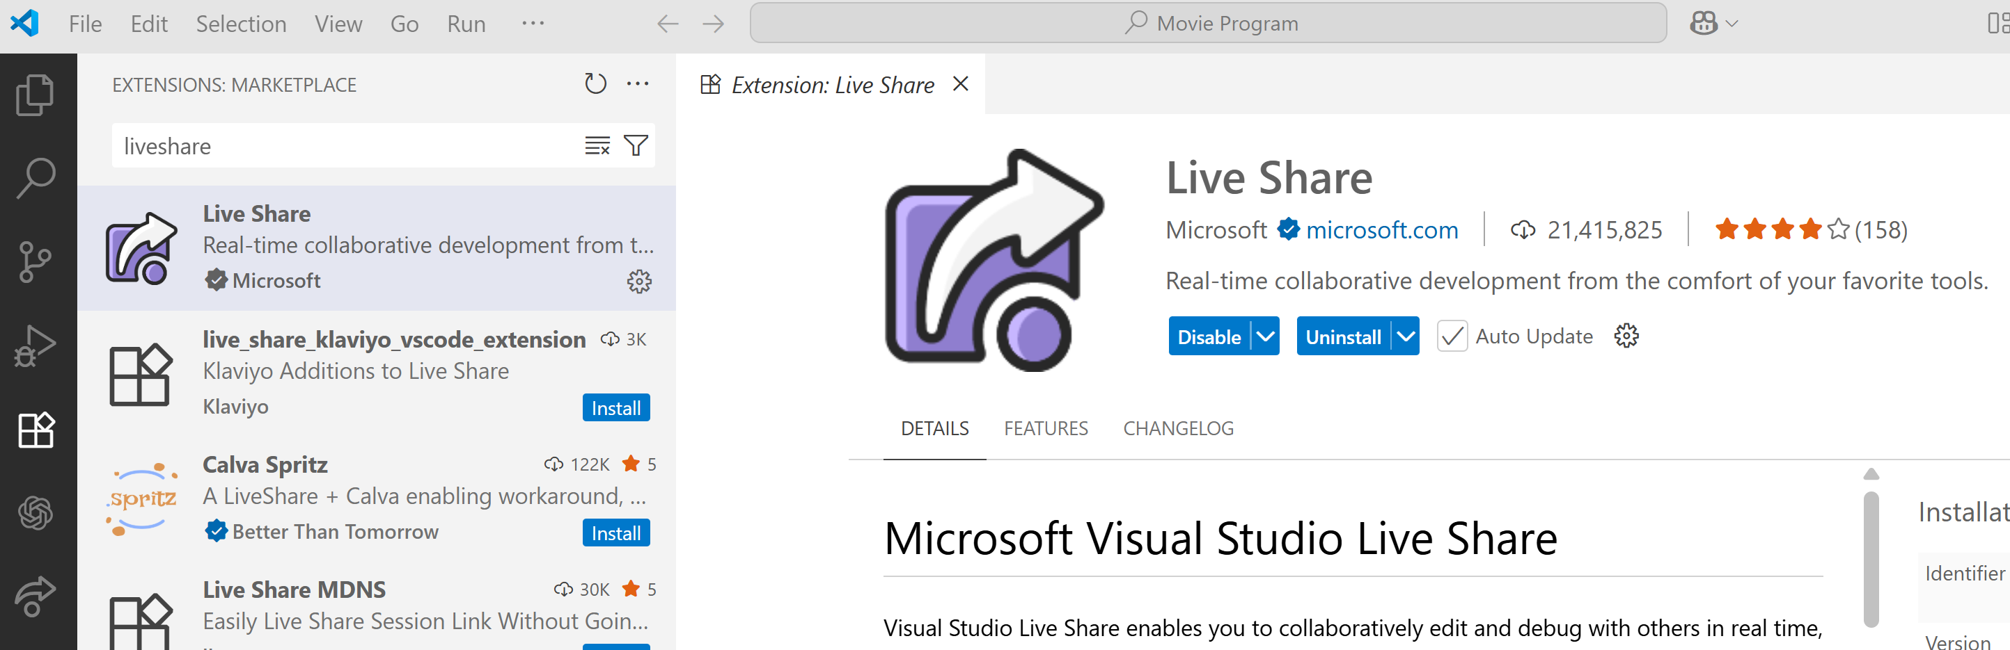

Policies for Lab 2

AI Policy for Lab 3: GitHub Copilot Use
You will be required to use GitHub Copilot as demonstrated in class to aid in creation and troubleshooting of your Lab 3 assignment.

Late Assignment Policy
- Lecture and lab programming assignments may be completed/submitted up to 2 days late at a penalty of 10 points off per day late.
- After 2 days, the assignment may not be submitted, and the grade will be a zero. Emailed submissions are not accepted.

Policy Concerning What You Can’t Use in LAB 3
You may NOT use the binary_search() function in the STL in C++ for this lab assignment. You must write your own binary search function. You will automatically get a 50% on this lab assignment if you use this function instead of implementing your own.
You also may NOT use the following in your lab assignment:
- while(true) or while(1)
- goto statements
- recursively calling main function
- exit()
- ternary operators (any syntax requiring a ‘?’)
- lambda functions
If you use any of the things listed above, then full points will be deducted for that criteria item in the rubric.

Lab Assignment Overview
You will design and implement a C++ program with three classes:
Two entity classes (e.g., Player, Coach, Vendor, Model, Actor, Animal, Song, Car, Soda, Pencil, Paper, )
One manager/owner class that contains a fixed-size array (from STL Array class) of one entity and provides:
- Sorted insertion (use std::sort function in <algorithm> library)
- Binary search by key
- Removal with compaction
- Save/load to CSV
- List all items
You will also write a driver that meaningfully tests your design.

SCENARIO OPTIONS (CHOOSE ONE)
Pick one scenario listed below and design three classes around it.
To help you all understand what you are required to do, I have created an example, which is described in the separate document named “SAMPLE OUTPUT – CSC 1310 Fall 2025 Lab 3.pdf”. You are not allowed to duplicate the theme/classes that I created but it will give you an idea of what you are required to do.
If you want to do something different then one of these options, run the idea by one of your lab instructors first to make sure it is ok.
- American Football Roster
  - Classes:
    - FootballRoster – owner class containing array of Player objects, contains binary search function searching on jerseyNumber of name
    - Player – entity class with attributes jerseyNumber (int, unique), name, position
    - Coach – entity class with attributes name, role (head, offense, defense, special/kick)
  - Driver Example: Add players, search player by jersey, remove a player, list full roster, save/load roster to/from file
- Bookstore
  - Classes:
    - Bookstore – owner class containing array of Book objects, contains binary search function searching on isbn
    - Book – entity class with attributes isbn (string, unique), title, price
    - Author – entity class with attributes name, birthyear, genre
  - Driver Example: Add books, search by ISBN, remove a book, save/load inventory to/from file
- Music PlaylistManager
  - Classes:
    - PlaylistManager – owner class containing array of Track objects, contains binary search function searching on trackID
    - Track – entity class with attributes trackID (int, unique), title, duration
    - Artist – entity class with attributes name, genre
  - Driver Example: Add books, search by ISBN, remove a book, export/import playlist to/from file
- Cybersecurity IncidentLog
  - Classes:
    - IncidentLog – owner class containing array of Incident objects, contains binary search function searching on a timestamp
    - Incident – entity class with attributes timestamp (string or int epoch, unique), type (phishing, malware, etc.), impactLevel (int)
    - Analyst – entity class with attributes name (string), employeeId (int), shift (string)
  - Driver Example: log incidents, search by timestamp, remove an incident, list recent ones, save/load incidents to/from file
- Travel Agency
  - Classes:
    - TravelAgency – owner class containing array of Trip objects, binary search on tripID
    - Trip – attributes: tripID (int, unique), destination, departureDate
    - Traveler – attributes: name, passportNumber, nationality
  - Driver Example: Add trips, search trip by ID, remove a trip, list all trips, save/load trips to/from file
- Farm Management
  - Classes:
    - FarmManagement – owner class containing an array of Crop objects, binary search on cropID
    - Crop – attributes: cropID (int, unique), type, season, yield
    - Farmer – attributes: name, experienceYears, farmSize
  - Driver Example: Add crops, search by cropID, remove crops, save/load Crops to/from file
- Police Case Database
  - Classes:
    - CaseDatabase – owner class containing an array of CaseFile objects, binary search on caseNumber
    - CaseFile – attributes: caseNumber (string, unique), type (theft, fraud, etc.), status
    - Officer – attributes: name, badgeNumber, role (detective, patrol, etc.)
  - Driver Example: Add cases, search by case number, remove closed cases, list all cases, save/load CaseFiles to/from file
- Biology Lab
  - Classes:
    - BiologyLab - owner class containing an array of Specimen objects, binary search on specimenID
    - Specimen – attributes: specimenID (int, unique), speciesName, collectionDate
    - Researcher – attributes: name, specialization, labID
  - Driver Example: Add specimens, search by ID, list species, save/load lab data to/from file

- Environmental Carbon Tracker
  - Classes:
    - CarbonTracker – owner class containing array of EmissionRecord objects, binary search on recordID
    - EmissionRecord – attributes: recordID (int, unique), date, CO2tons
    - Facility – attributes: name, location, sector
  - Driver Example: Add emission records, search by recordID, remove emission record, save/load emission records to/from file
- Botonist Botanical Garden
  - Classes:
    - BotanicalGarden – owner class containing array of Plant objects, binary search on plantID
    - Plant – attributes: plantID (int, unique), species, habitat
    - Botanist – attributes: name, expertise, yearsExperience
  - Driver Example: Add plants, search by plantID, remove plants, save/load plants to/from file
- Housing Market
  - Classes:
    - HousingMarket – owner class containing array of Property objects, binary search on propertyID
    - Property – attributes: propertyID (int, unique), address, price
    - Agent – attributes: name, licenseNumber, agency
  - Driver Example: Add properties, search by propertyID, remove properties, save/load properties to/from file

Driver Requirements
Your Driver.cpp must:
- Provide a menu (or scripted test driver) to:
  - Add objects (in random order, verify they are stored sorted)
  - List all objects
  - Search using binary search algorithm (both hit and miss cases)
  - Remove an object by key
  - Save objects from array into .csv file
  - Load data from .csv file, create objects.
- Provide clear console feedback and handle invalid input gracefully

Binary Search Requirement
The owner/manager class must:
- Maintain the array in sorted order by the chosen key
- Provide a binarySearchByKey function (iterative or recursive)

Documentation & Commenting
You must have a comment above each function (other than mutators/accessors) in all .h and .cpp files that says the function name, function purpose, parameters, and what it returns.
You must also have a comment block at the top of each file saying the filename, authors (put GitHub Copilot as first author and your name / partner name after), date, and purpose of the particular file.

Sample Output
You must create a document named Sample Output.pdf that demonstrates the following for your program:
- Successful add of at least 10 manager/owner objects
- Duplicate key rejection
- Binary search hit of element (object) in array
- Binary search miss
- Successful removal of at least two objects
- Save to csv file
- Load from csv file

Reflection Document
Write a 150–250-word reflection in a document that you will save as Reflection.pdf on using GitHub Copilot and address the following questions:
- When was GitHub Copilot helpful?
- Where did it struggle?
- What questions do you still have about using GitHub Copilot?

Don’t Forget to Fill out the Lab Report
You will fill out this lab report for every lab and it is part of your grade. To get credit, you must upload a screenshot of the confirmation page to this lab assignment.
Name your screenshot lab3ReportProof. (any file type if instructor can open & see image)
Lab Report Link: https://tntech.co1.qualtrics.com/jfe/form/SV_9HqtICq7g8FnDDw

What to Turn in to ilearn
Create a zip file named containing the following files and upload it to ilearn in the Lab 3 assignment.
- Three .h files containing the three class declarations
- Driver.cpp
- Sample Output.pdf
- Reflection.pdf
- Lab3ReportProof

